**Email Clients/Broker/TPAs can send to Members:**

Send email to all members enrolled in the Prime benefit.

Subject: Introducing PrimeCentral™!

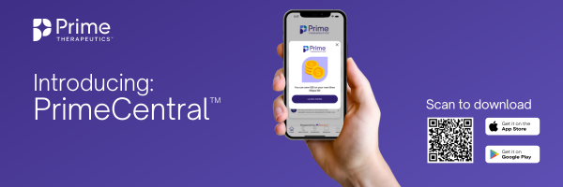

We're excited to introduce you to the best way to manage your prescriptions – PrimeCentral!

**Scan the QR code above with your smartphone to download the app.**

With PrimeCentral, you can:

* **Stay informed:** easily access your current prescriptions, ID card, and receive savings alerts.
* **Find the best option for you:** at the doctor’s office or from the comfort of the couch, compare prices for medications and pharmacies.
* **Save with a tap:** seamlessly switch to a more affordable medication or pharmacy directly through the app.

Need help with the app? Call 888-302-1469 or email PrimeCentral@levrx.com.